**OUD Connector: Installation and Configuration**

This article demonstrates the configuration required to install OIM Generic LDAP connector (named as OID-11.1.1.6.0) to integrate OIM with OUD

a) Download the latest version of connector from Oracle website. I am using OID-11.1.1.6.0.zip

b) UNZIP it and move it to /ORACLE_HOME/server/ConnectorDefaultDirectory

c) LOGIN to sysadmin console

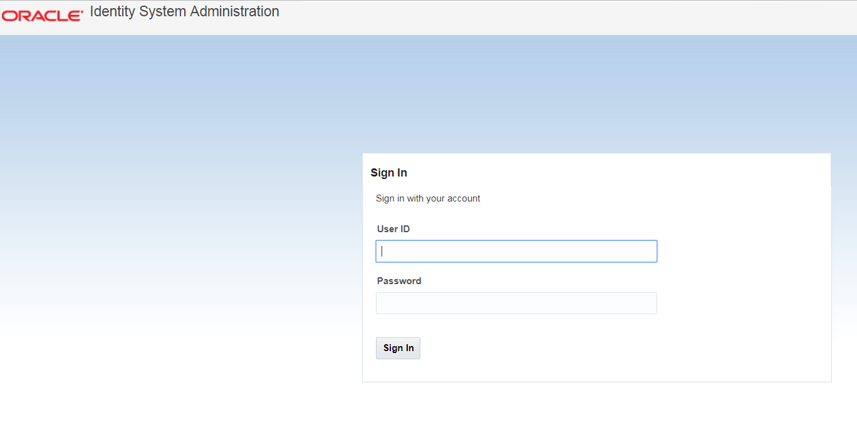

d) Go to Manage Connectors and click on that

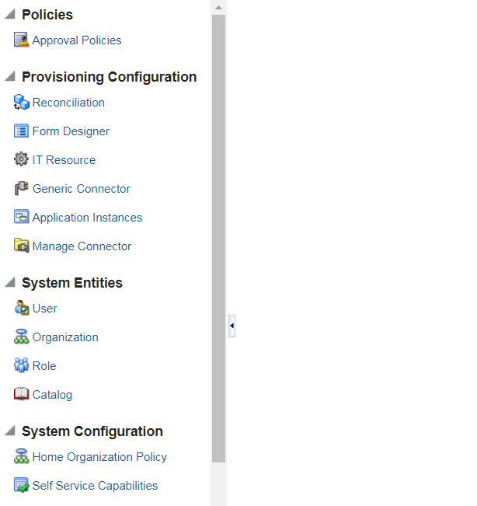

e) A new Connector Management window will pop up. Click on Install button

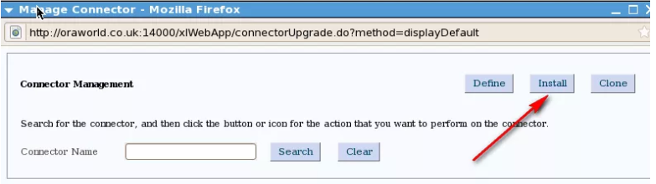

f) From the Connector List list, select ODSEE/OUD/LDAPV3 Connector 11.1.1.6.0.

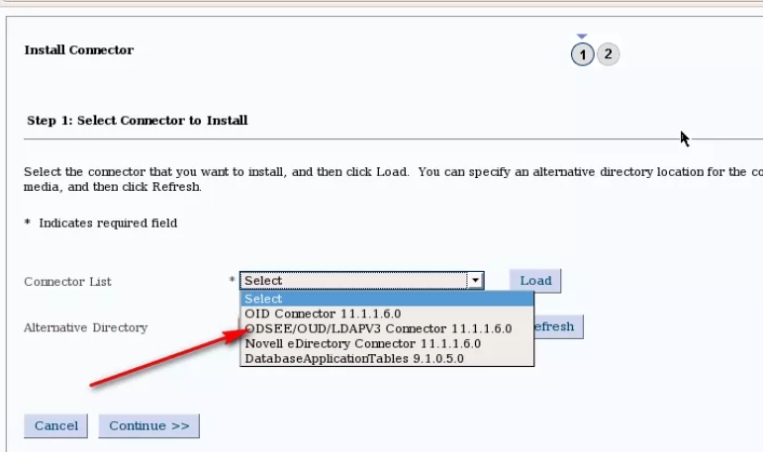

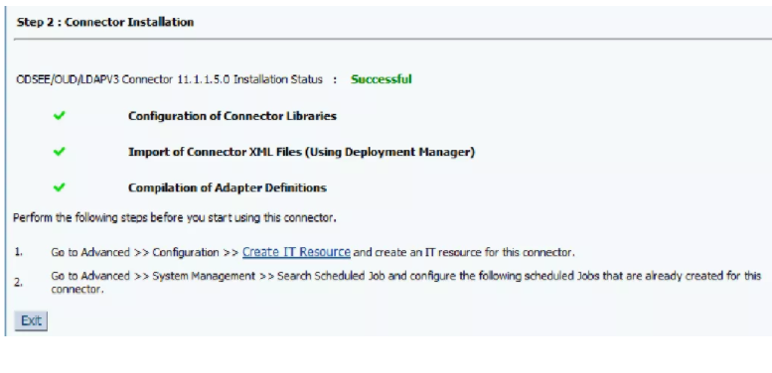

1. Next we will create a IT Resource. Click IT Resource under Configuration. A new pop-up window will open.

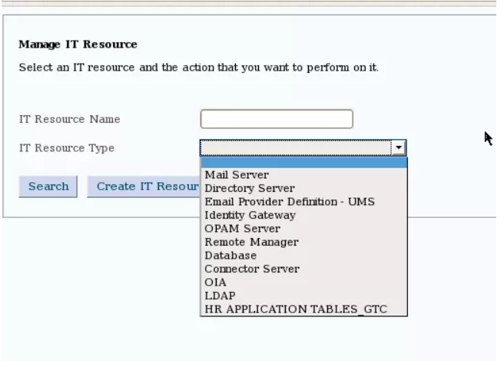

g) Choose IT Resource Name = Enterprise Directory – OUD and IT Resource Type = LDAP & Continue.

k) Specify IT Resource Parameter Values page, specify values for the parameters of the IT resource, and then click Continue.

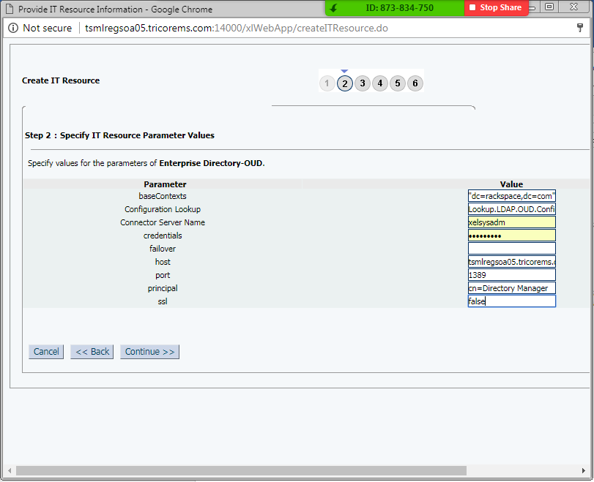

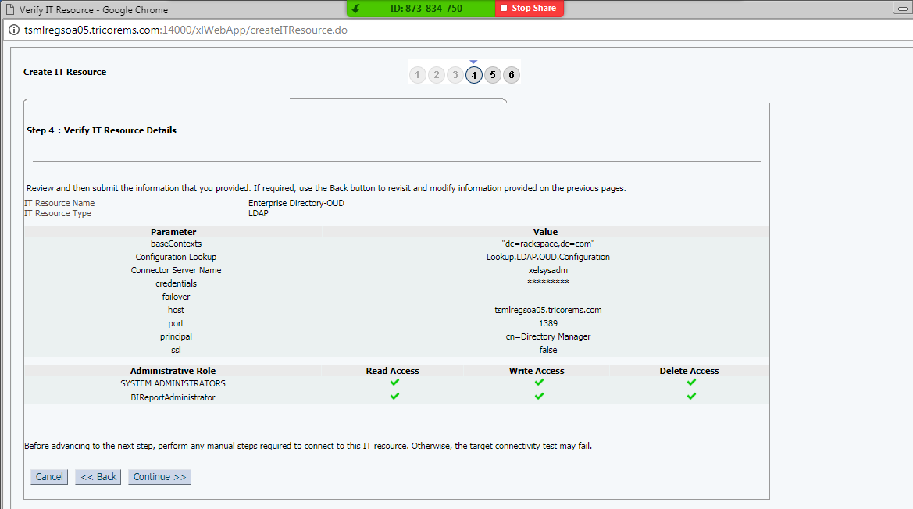

l) Click on Continue until you Finish.

m) Now we will create and activate Sandbox.

n) NEXT we will create an Application Instance for the relevant instance of OUD server. Click Application Instances under Configuration

n) Click Create and fill the relevant data

Name: EnterpriseDirectoryOUD

Display Name: Enterprise Directory – OUD

Description: Target Resource

Disconnected: Unchecked

Resource Object: Search and Assign LDAP User

IT Resource Instance: Search and Assign Enterprise Directory – OUD

Form: Leave it blank

o) SAVE it.

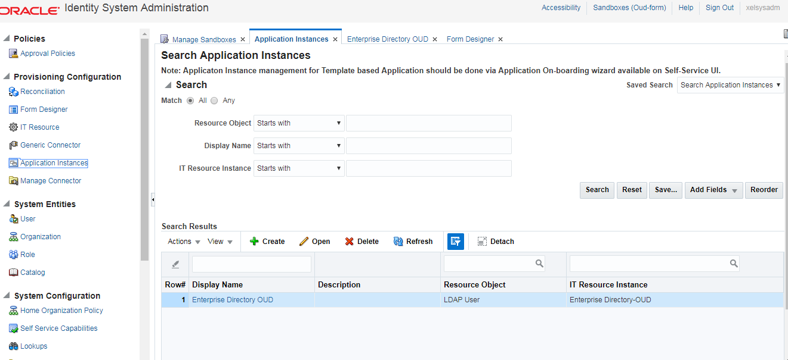

p) Now click on Form Designer on the left pane of Admin console.

q) Search for the IT Resource

r) Give the form name as OUD Form click on create and back to the Application Instance

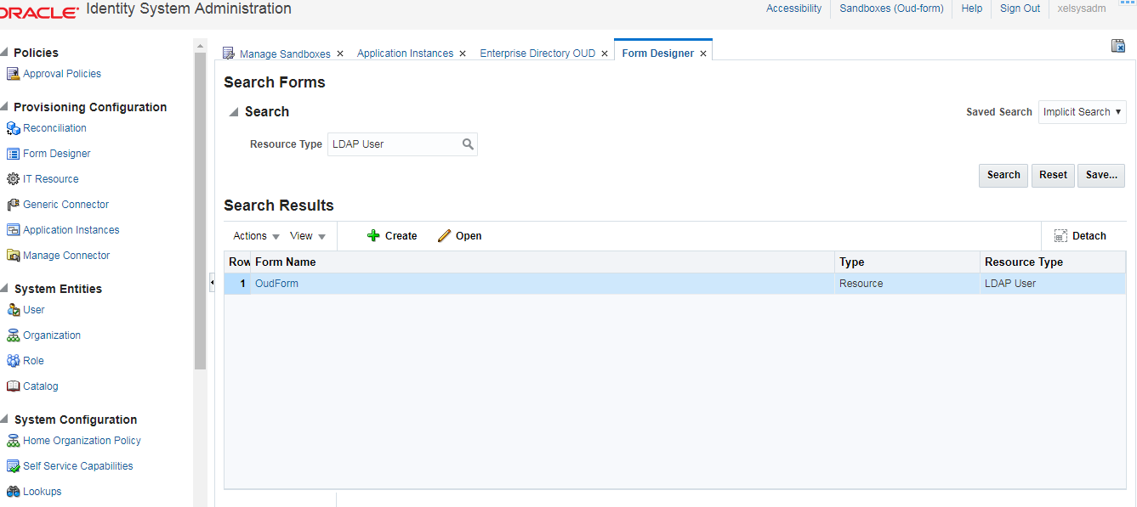

s) Refresh at the Form on that page and select OUD Form created before and apply

t) Now close all the tabs and publish the sandbox.

u) Go to schedulers search for Catalog synchronisation job and run.

**To run the ConnectorUninstall script for uninstalling the connector:**

Set values in the properties file used by the script.

The ConnectorUninstall.properties file is a viable in *OIM_HOME*/server/bin. This file contains information that is used by the script for deleting connector objects.

Open the properties file in a text editor, and then set values for the following properties:

DatabaseURL: Enter the JDBC URL for the Oracle Identity Manager database in the following format:

DBUserName: Enter the user name of an Oracle Identity Manager database.

DBType: Specifies the type of database.

LogLevel: Enter one of the following as the log level: DEBUG, WARN, INFO, or ERROR.

Location: Enter the directory location where you want to have all the log files generated by the Uninstall utility.

If the Uninstall utility completes successfully, then the ConnectorUninstall.log file, along with <ResourceObject>.log files are generated.

If the Uninstall utility fails, then the ConnectorUninstall.log file along with the ConnectorUninstall_Error.log file are generated.

For example, if the Uninstall utility of OID Connector succeeds, then the following logs will be generated:

* + - ConnectorUninstall.log
    - LDAP User.log
    - LDAP Group.log
    - LDAP Oraganization Unit.log
    - LDAP User Trusted.log

If the Uninstall utility of LDAP Connector Fails, then the following logs will be generated:

ConnectorUninstall.log

ConnectorUninstall_Error.log

ConnectorName: The value that you set for this property depends on your requirement. If you want to delete a specific connector, then enter the name of the connector. The name that you enter must be the same as the name shown in the search results displayed through the Manage Connector feature. For example, enter LDAP if you want to delete the Microsoft Active Directory connector.

Release: The value that you set for this property depends on your requirement. If you want to delete a specific connector, then enter the release number of the connector. The release number that you enter must be the same as the release number shown in the search results displayed through the Manage Connector feature.

ObjectType: The value that you set for this property depends on your requirement:

If you want to uninstall a connector, then ensure that the ObjectType property is not assigned a value.

If you want to delete adapters, lookup definitions, resource objects, or scheduled task, then enter **Adapter, Lookup, ResourceObject**, **or ScheduledTask**respectively.

Example: ResourceObject

ObjectValues: Enter a semicolon-separated list of object values.

Example: LDAP User; LDAP Group

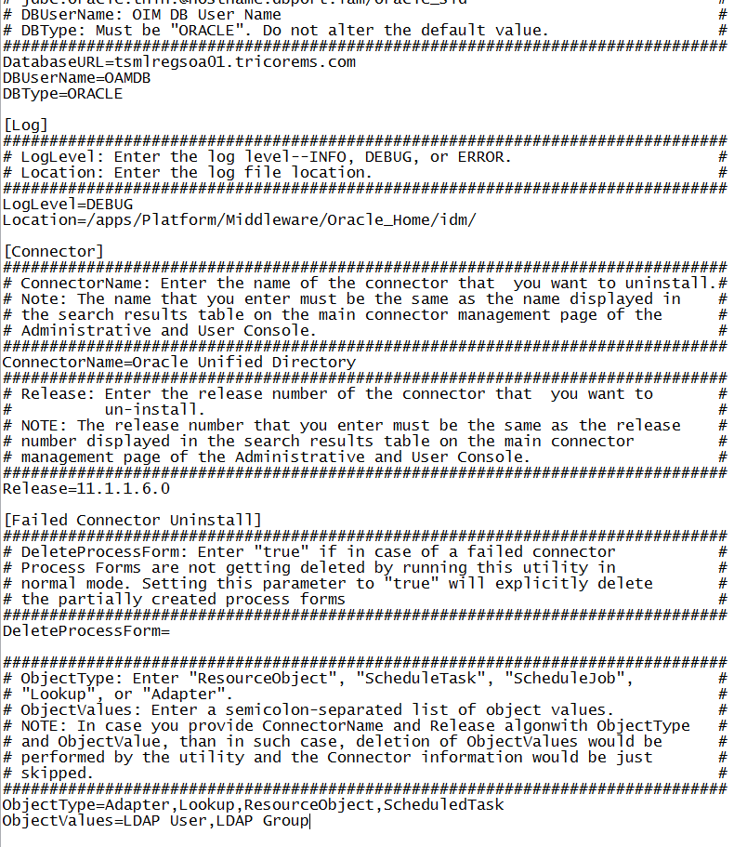

In a command window, change to the *OIM_HOME*/server/bin directory and then run the script, sh uninstallConnector.sh (or bat file).

While the script runs, logs will be generated at the location provided.

After you run the utility, you will be prompted to enter following information:

* + Oracle Identity Manager Database Password
  + Oracle Identity Manager Administrator Name
  + Oracle Identity Manager Administrator Password
  + Oracle Identity Manager Server t3 URL
  + Confirmation for the deletion of the connector/object(s)

Try to change for updating and Checking the Xml config Discovery

